According to the case studies and surveys in 2016

The usage and spending on videos and images has been rapidly increased as 67% spend more on videos for selling their products. By this we can analyze that Video usage is accelerating at a phenomenal rate, but a number of businesses (39%) – for whatever reason – are yet to add it to their marketing strategy. Spending is also on a dramatic upward curve, and businesses looking to cut their video budget are in a very small minority (8%). .This will be useful for us to approach them and make them our clients.

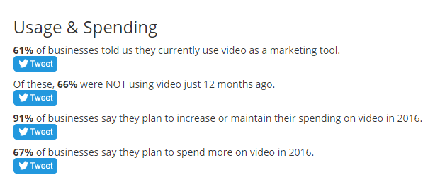

Ref: <https://www.wyzowl.com/video-marketing-statistics-2016.html>

For some business have not started using video promotions as they feel this as an very expensive .



Ref: <https://www.wyzowl.com/video-marketing-statistics-2016.html>

And According to Invodo

There are about 92% of mobile video consumers who share videos with others platform .

Ref:- <http://www.insivia.com/50-must-know-stats-about-video-marketing-2016/>

In August 2012 survey,

46% of adult internet users post original photos or videos online that they themselves have created.

We call them creators.

41% of adult internet users take photos or videos that they have found online and repost them on sites designed for sharing images with many people. We call them curators.

Overall, 56% of internet users do at least one of the creating or curating activities we studied and 32% of internet users do both creating and curating activities.

So concluding we can say that there are potential commercial users ie brands and company who are interested for cheap and good images ,videos and customized product which we provide.

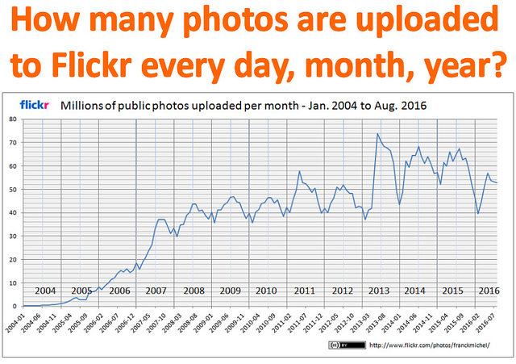

If flickr does why not we.

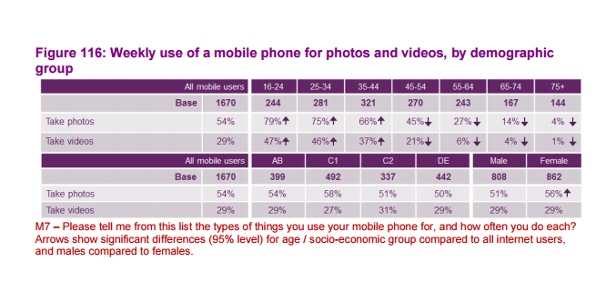

These are our potential customers which are for uploading and downloading images and vedios .